**AQUA: SMART WATER SUPPLIER**

Submitted in partial fulfillment of the requirements of the degree of

Bachelor of Engineering in Information Technology

By

**VIVEK KHADE 18101C2041**

**SOHIL GURUNG 18101C2042**

**RUCHIR TAYSHETE 18103C2041**

Under the Guidance of

**Prof. AJITKUMAR KHACHANE**

Department of Information Technology



Vidyalankar Institute of Technology

Wadala(E), Mumbai - 400437

University of Mumbai

2020-2021

## CERTIFICATE OF APPROVAL

This is to certify that the project entitled

**“AQUA: SMART WATER SUPPIER”**

is a bonafide work of

VIVEK KHADE 18101C2041 SOHIL GURUNG 18101C2042 RUCHIR TAYSHETE 18103C2041

submitted to the University of Mumbai in partial fulfillment of the requirement for the award of the

degree of

**Undergraduate** in **“INFORMATION TECHNOLOGY”**.

|  |  |  |
| --- | --- | --- |
| Guide | Head of Department | Principal |
| (Prof. Ajitkumar Khachane) | (Dr. Deepali Vora) | (Dr.S.A.Patekar) |

## Project Report Approval for B. E.

This project report entitled ***AQUA: SMART WATER SUPPLIER*** by

1. ***VIVEK KHADE (Roll No. 18101C2041)***
2. ***SOHIL GURUNG (Roll No. 18101C2042)***
3. ***RUCHIR TAYSHETE (Roll No. 18103C2041)***

is approved for the degree of ***Bachelor of Engineering in Information Technology***

Examiners

1.

2.

Date:

Place:

**DECLARATION**

I declare that this written submission represents my ideas in my own words and where others' ideas or words have been included, I have adequately cited and referenced the original sources. I also declare that I have adhered to all principles of academic honesty and integrity and have not misrepresented or fabricated or falsified any idea/data/fact/source in my submission. I understand that any violation of the above will be cause for disciplinary action by the Institute and can also evoke penal action from the sources which have thus not been properly cited or from whom proper permission has not been taken when needed.

Name of Student Roll No. Signature

1. Vivek Khade 18101C2041
2. Sohil Gurung 18101C2042
3. Ruchir Tayshete 18103C2041

Date:

#### ACKNOWLEDGEMENT

We are honored to present “**AQUA: SMART WATER SUPPLIER**” as our B.E Final Year Project. We are using this opportunity to express our profound gratitude to our principal “**Dr. Sunil Patekar**” for providing us with all proper facilities and support.

We express our deepest gratitude towards our HOD **“Dr. Deepali Vora”** for his valuable and timely advice during the various phases in our project. We would like to thank our project guide **“Prof. Ajitkumar Khachane”** for support, patience and faith in our capabilities and for giving us flexibility in terms of working and reporting schedules. Finally, we would like to thank everyone who have helped us directly or indirectly in our project.

We would also like to thank our staff members and lab assistant for permitting us to use computer in the lab as when required. We thank our college for providing us with excellent facilities that helped us to complete and present this project.

Vivek Khade

Sohil Gurung

Ruchir Tayshete

### ABSTRACT

### 

Online shopping advancements have been so drastic that it has evolved to be a part of our life. Today customer does not drive down to some shop for buying a product but preferably check over the internet for price, offers, reviews and order online. In most of the metro Politian cities water containers are purchased from shops for their basic needs of day today life.

The current system working procedure in those cities is where customer calls/drives down to shop to order the water container by providing the shopkeeper a deliverable address and then a delivery person delivers the order to customer’s doorstep, as this system works totally offline and has lot of drawbacks. The major drawbacks in current offline system are repeated calls from and to customer, if multiple orders are placed from same locality the delivery person travels multiple times, there is no track of order, etc.

This paper proposes an android application for water container ordering and delivery management system, where customer can order over an application by searching the nearby shops which provide the service and make payment online. This proposed system helps in overcoming the major drawbacks of current system. This application provides assistance modules for shopkeeper; it moderately helps in developing digitally empowered society.

### TABLE OF CONTENTS

Acknowledgement vi

Abstract vii

Table of Contents viii

List of Figures ix

1. Introduction 1
   1. Basic Concept 2
   2. Problem Statement 3
   3. Need 3
   4. Aim and Objective 4
   5. Overview of Project 4
2. Literature Survey 5
3. System Design 8
   1. Block Diagram 9
   2. Proposed System 11
   3. Hardware & Software Analysis 14
      1. Requirement Analysis 14
      2. System Design 14
   4. Process Model 22
   5. Feasibility Study 26
   6. Data Flow Diagrams 28
   7. UML Diagrsams 29
      1. Use Case Diagram 29
      2. Sequence Diagram 31
      3. State Level Diagram 32
      4. Component Diagram 33
      5. Activity Diagram 34
4. Planning & Scheduling 35
   1. Gantt Chart 36
   2. PERT 37
   3. Timeline 38
   4. Work Breakdown Structure 38
5. Testing & Maintenance 39
   1. Testing 40
   2. Maintenance 46
6. System Implementation 48
   1. Results 49
7. Conclusion & Future Scope 57
   1. Conclusion 58
   2. Future Scope 58

**8. References**………..…….……..........................................................................

**Paper Published**……............................................................................................

**Certificates**…………............................................................................................

### List Of Figures & Table Figures

|  |  |  |
| --- | --- | --- |
| **Sr No.** | **Content** | **Page No.** |
| 3.1 | Block Diagram | 9 |
| 3.4 | 3.4.1 System Development Lifecycle | 19 |
| 3.5 | Process Model | 23 |
| 3.7 | 3.7.1 Admin DFD Diagram | 28 |
| 3.7.2 Traffic Police DFD Diagram | 28 |
| 3.8 | 3.8.1(a) Admin Use Case Diagram | 29 |
|  | 3.8.1(b) Traffic Police Use Case Diagram | 30 |
|  | 3.8.2 Sequence Diagram | 31 |
|  | 3.8.3 State Level Diagram | 32 |
|  | 3.8.4 Component Diagram | 33 |
|  | 3.8.5 Activity Diagram | 34 |
| 4.1 | Gantt Chart | 36 |
| 4.2 | 4.2.1 : Pert Table | 37 |
| 4.2.3 : Pert Chart | 37 |
| 4.3 | Timeline | 38 |
| 4.4 | Work Breakdown Structure | 38 |
| 5.1 | Software Testing Model | 41 |

|  |  |  |
| --- | --- | --- |
| 6.1 | * + 1. Home Page 6.1.2        1. : User Login Page        2. : Admin Login Page        3. : Traffic Police Login Page 6.1.3  1. : Add User 2. : Add Traffic Police 3. : Add Penalty 6.1.4    1. : User List    2. Traffic Police List    3. :Penalty List       1. :Penalty History       2. NFC/QR Scan Page       3. User Details       4. Users Penalty | 49 |
| 49 |
| 50 |
| 50 |
| 51 |
| 51 |
| 52 |
| 52 |
| 53 |
| 53 |
| 54 |
| 54 |
| 55  56 |

**CHAPTER 1**

# INTRODUCTION

### INTRODUCTION

##### Basic Concept

When a breakage occurs in the water pipeline, water crisis occurs. Due to the breakage, the water gets wasted and the area where the water supposed to go becomes impossible. Hence those areas suffer from water crisis until the pipeline is not fixed. During the crisis, the people living in those areas are not able to get water directly; hence they need to contact the nearest water tanker supplier who can provide the supplies to those people living in those areas.

This traditional approach takes lot of time and efforts to contact to the supplier. And there becomes a good possibility of miscommunication in terms of water requirements, the location and address and contacting the supplier itself becomes a tedious task. To overcome this problem, this project tries to create a platform for the end users who need water.

This platform will connect the water suppliers to the end consumers with the help of a mobile application. Where users can put their location, contact details and requirements and order the supplies in a very efficient way. The app will have more features apart from this such as supplier’s shop location, for the latest updates and so on which we will be looking further in the document.

The aim of this project is to provide a user-friendly application for its users. It is developed using Java, XML and Android Studio IDE. The application will be very useful for having update on water crisis and ordering water online.

##### Problem Statement

Traditionally, to order water supply from a supplier, the user orders it from a phone call. This results in more manual work and good chance of miscommunication while giving and receiving the details like the location, requirements, and the user who ordered the supply. To overcome this problem, we proposed an idea of creating a mobile application through which the user will be able to order the water supply as per their requirements.

This leads to less manual work and very less chance of miscommunication due to less interaction with the supplier. With this, the work becomes more efficient, and the supplier can bring the supplies directly to the location. In our day and age where people use lots of water resources for even small activity, one should know whether he will receive water today or not. Till now it’s not possible to notify each and every individual about the today’s condition regarding the water supplies.

Hence, we decided to add a feature of news section where admin can push notifications on the current scenario of the supplies. If the user orders a water tanker from a supplier, the user does not know the exact location of where the supply has reached. Hence in our project, the user will be able to send the exact coordinates to the supplier for better navigation.

In traditional manner, one does not know the number of water suppliers in their locality, hence we will be implementing a feature where the user will get the location and contact details of all the suppliers in their location. These are the above problem statements which we came across and try to solve them in our final year project. This project aims to develop an android application to solve problems during a water crisis by providing various suppliers location and details and a support system for their query and a notifier by creating a news section on the app.

And along with this the objective of our final year project is to show the marked area on the map which will reflect water crisis affected areas. The objective is also to create a feedback section for better understanding about the user’s requirements. The water ordering system will have an authentication unit which will authenticate users and activate the water ordering system for him/her. The objective of this project is also to have an easy to use and creative user interface and an efficient programming done to the application for fast user experience.

##### Need

Previous System was based on catching of people committing crimes & fining them via a challan of paper which is similar to the bill we get on buying of goods. Maintaining the record of these receipts for police officer as well as the offender was difficult. It also involved corruption as offender used to bribe the police officer & let go without filling the challan.

In this system, all the records of the offenders will be available once the NFC cards are scanned, there is a least chance of bribing the police officers & the payment will be done on the spot by the balance in the NFC card. Due to the records serious offenders committing same crime can be punished heavily or the license will be seized.

##### Aim and Objective

To overcome that corruption problem we made our system that automatic fine pay to government. And to store all details of license holder in system.

##### Overview of Project

* Simple operation: the app is simple and intuitive. All necessary actions are displayed graphically.
* The latest technologies: the checks are performed using NFC (near field communication) technology. The license must have embedded NFC chips that can be read by the smartphone app.
* Maximum security: the embedded NFC chips can be provided with a predetermined breaking point. An attempt to detach the chip from the license would irrevocably destroy the chip.
* Data protection: no personal information would be stored on the license's NFC chip.
* Legality: this automated license check system has been developed on the basis of German law

**CHAPTER 2**

# LITERATURE SURVEY

### LITERATURE SURVEY

1. **Mobile Commerce**

Mobile commerce gives beneficial chance for service and mobile devices. On m-commerce, transaction is made using wireless devices and requires data connection to trade information, service and or good. M-commerce transaction can be defined as any economical transaction which done through mobile device that use telecommunication network to establish communication with e-commerce infrastructure. M-commerce development is supported by mobile device users who significantly improve in number. M-commerce become detrimental to provide service, information and entertainment for travelling people. Through m-commerce service within mobile device, any kind of service can be enjoyed in any place and any time.

1. **Near Field Communication (NFC)**

Near Field Communication is a wireless close-range connectivity technology which allows data trade between two gadgets. NFC commonly integrated within mobile devices. This will allow the device to establish communication with Simcard or other reader devices.

NFC works using 13,56 MHz radio frequency. This technology optimize works under the the space of 20 cm. Transmittable data is only less than 1Mbit. This technology developed in 2004. NTC got the transfer speed of 424 Kbps. Moreover, the cell phone can also be used as payment tool and an automatic machine, toll payment, and some other transactions. NFC application is also can be used on a public transportation as a substitute of wallet and as a tool to License penalties.

Basically NFC has 2 different communications which work on different speed, consist of:

* 1. Active NFC Mode, in this mode, inisiator and target use self-established radio frequency to

communicate.

* 1. Passive NFC Mode, in passive mode, target answer command made by inisiator to call modulation scheme. Inisiator do the radio frequency creation.

1. **Android Development**

Android Inc. established at 2003 in Palo Alto, California, US by Andy Rubin, Rich Miner, Nick Sears, and Chris White. In 2005, Google Inc. aquisizes Android Inc. Around 2 years after Google aquisized Android, Google with Open Handset Alliance (OHA) published Google Android SDK (Software Development Kit). OHA consists of several big mobile device manufacturers such as HTC, Samsung, Sony Ericsson, etc.

Since the Google Android SDK launch, the development of Android OS becomes rapidly faster. Proven at 2009, the features of Android OS experiences 3 significant changes. The development of this OS doesn’t at this stage. In the end of 2011, Android just releases its latest OS, Android 4.0, with the code name of Ice Cream Sandwich.

1. **Android and Near Field Communication (NFC)**

The usage of NFC can be done through 3 major ways:

Card emulation, reader mode, peer to peer (P2P) mode. The function of NFC introduced by Google into Android 2.3 (API level 9) device. In Android 2.3, the ability of device is limited in only reading the tag. In Android 2.3.3 (API level 10), data writing and trading ability through mode Peer to Peer (P2P) began to be implemented within android devices.

The NFC android package provides access to NFC function, allows application to read NDEF message (NFC Data Exchange Format) which located at NFC tag. On android NFC located several classes which can be used to running NFC function.

**CHAPTER 3**

# SYSTEM DESIGN

### SYSTEM DESIGN

##### Block Diagram

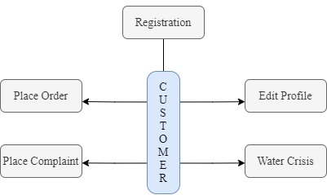

Figure 3.1: Block Diagram

**Explanation :**

**Near Field Communication :**

Near Field Communication is a wireless close-range connectivity technology which allows data trade between two gadgets. NFC commonly integrated within mobile devices. This will allow the device to establish communication with simcard or other reader devices. NFC works using 13,56 MHz radio frequency. This technology optimizely works under the space of 20 cm. Transmittable data is only less than 1Mbit. This technology developed in 2004. NFC ConceptNevertheless, the

main reason to apply this technology is to be implemented within ticketing application, payment application and public transportation application. When a cell phone equipped with NFC deviced

,that particular cellphone can be used as ticket of conference or theme park and also a “mini wallet” which can be used in certain time. Moreover, the cell phone can also be used as payment tool and an automatic machine, toll payment, and some other transactions. NFC application is also can be used on a public transportation as a substitute of wallet and as a tool to ticket data writting. Basically NFC has 2 different communications which work on different speed, consist of:

1. Active NFC Mode, in this mode, inisiator and target use self-establised radio frequency to communicate.
2. Passive NFC Mode, in passive mode, target answer command made by inisiator to call modulation scheme. Inisiator do the radio frequency creation.

**Android Based NFC Reader:**

The usage of NFC can be done through 3 major ways: card emulation, reader mode, peer to peer (P2P) mode. The function of NFC introduced by Google into Android 2.3 (API level 9) device. In Android 2.3, the ability of device is limited in only reading the tag. In Android 2.3 data writing and trading ability through

mode Peer to Peer (P2P) began to be implemented within android devices. The .nfc android package provides access to NFC function, allows application to read NDEF message (NFC Data Exchange Format) which located at NFC tag. On android.nfc , located several classes which can be used to running NFC function.

##### Proposed System

Many modern smart phones and tablets have an integrated scanner that can read NFC chips. All one needs to do for driver's licence checks is attach a single low-cost NFC chip to the driver's licence.

The NFC chip stores a unique combination of numbers. This ID will be read by the smartphone and the NFC to web app with the underlying NFC technology and uniquely associated with the driver's master data in the web application.

Now the drivers can perform the automated checks with NFC to web application. They just need to hold their driver's licences up to their smartphones. The phone scans the chip and fetch the unique id from the chip. The data connection can be either through a mobile data connection or via a local wireless network.

**Modules of the Project Admin Module:-**

1. admin can login into the application.
2. admin check the documents and if those documents are legal then he will make a new user account into the application and provide a new license to the user.
3. after creating a new user account user will get the username and password by mail.

**Traffic Police Module:-**

1. Traffic police login to the android application.
2. if any user caught by traffic police then police will get the driving licence and tap using android phone.
3. after tapping, police can view the previous records, can placed a new complaint.
4. after placing a new complaint the fine amount will get deduct from a total balance of the user.

**User Module:-**

1. User can login into the system using username and password.
2. User can view the complaints which are placed against him.

**Theoretical Analysis of The Topic:**

**Android for Mobile Application**



**Android** is an operating system for mobile devices such as smart phones and tablet computers. It is developed by the Open Handset Alliance led by Google.. Google released most of the Android code under the Apache License, a free software license. The Android Open Source Project (AOSP) is tasked with the maintenance and further development of Android. Android consists of a kernel based on the Linux kernel, with middleware, libraries and APIs written in C and application software running on an application framework which includes Java-compatible libraries based on Apache Harmony. Android uses the Dalvik virtual machine with just-in-time compilation to run compiled Java code. Android has a large community of developers writing applications ("apps") that extend the functionality of the devices. Developers write primarily in a customized version of Java. Apps can be downloaded from third-party sites or through online stores such as Android Market, the app store run by Google.

**ASP.NET**

ASP.NET is more than the next version of Active Server Pages (ASP); it is a unified Web development platform that provides the services necessary for developers to build enterprise- class Web applications. While ASP.NET is largely syntax-compatible with ASP, it also provides a new programming model and infrastructure that enables a powerful new class of applications. You can migrate your existing ASP applications by incrementally adding ASP.NET functionality to them. ASP.NET is a compiled .NET Framework -based environment. You can author applications in any .NET Framework compatible language, including Visual Basic and Visual C#. Additionally, the entire .NET Framework platform is available to any ASP.NET application. Developers can easily access the benefits of the .NET Framework, which include a fully managed, protected, and feature-rich application execution environment, simplified development and deployment, and seamless integration with a wide variety of languages.

##### Hardware & Software Requirements

##### Requirement Analysis

The requirement analysis lists all the required features of the project and characterizes their individual requirements. After performing all the analysis we point out the requirements for designing this software.

1. Hardware Requirement
   * NFC Tags.
   * NFC based Android mobile.
   * INTEL processor IV and above.
   * 1 GB RAM.
   * 160 GB Hard Disk.
2. Software Requirement
   * Visual Studio 2010.
   * MS SQL Server 2005.
   * SDK for Android 4.2.
   * Windows Operating System.
   * Eclipse.

##### System Design

* + - * User Manual:

**About software ;**

* 1. **Eclipse:**

Development of Android Application mainly consist of following Packages.

* + 1. Activities:

An *activity* represents the visual representation of an Android application. *activities* use *views*, i.e. user interface widgets as for example buttons and *fragments* to create the user interface and to interact with the user.An Android application can have several *activities*.

* + 1. Fragments:

Fragments are components which run in the context of an activity.

* + 1. Views and layout manager:

*Views* are user interface widgets, e.g. buttons or text fields.

* + 1. Device configuration specific layouts:

The user interface for *Activities* is typically defined via XML files (layout files).

* + 1. Content providers:

A *content provider* provides a structured interface to application data. Via *content provider* your application can share data with other applications. Android contains an SQLite database which is frequently used in conjunction with a *content provider*. The SQLite database would store the data, which would be accessed via the *content provider*.

* + 1. Services:

*Services* perform tasks without providing a user interface. They can communicate with other Android components and notify the user via the notification framework in Android.

* + 1. Intents:

*Intents* are asynchronous messages which allow the application to request functionality from other Android components, e.g. from *services* or *activities.*

An application can call a component directly (*explicit Intent*) or ask the Android system to evaluate registered components based on the *intent* data (*implicit intents*). For example the application could

implement sharing of data via an *intent* and all components which allow sharing of data would be available for the user to select. Applications register themselves to an *intent* via an *intent filter*.

*Intents* allow an Android application to start and to interact with components from other Android applications.

* + - 1. **Android Development Kit (SDK) :**

The *Android Software Development Kit* (SDK) contains the necessary tools to create, compile and package Android application. Most of these tools are command line based.

The Android SDK also provides an Android device emulator, so that Android applications can be tested without a real Android phone. You can create *Android virtual devices* (AVD) via the Android SDK, which run in this emulator.

The Android SDK contains the *Android debug bridge* (adb) tool which allows to connect to an virtual or real Android device.

* + - 1. **Android Development Tools :**

Google provides the *Android Development Tools* (ADT) to develop Android applications with Eclipse. ADT is a set of components (plug-ins) which extend the Eclipse IDE with Android development capabilities.

ADT contains all required functionalities to create, compile, debug and deploy Android applications from the Eclipse IDE. ADT also allows to create and start AVDs.

The Android Development Tools (ADT) provides specialized editors for resources files, e.g. layout files. These editors allow to switch between the XML representation of the file and a richer user interface via tabs on the bottom of the editor.

* + - 1. **Dalvik Virtual Machine :**

The Android system uses a special virtual machine, i.e. the *Dalvik Virtual Machine* to run Java based applications. Dalvik uses an own bytecode format which is different from Java bytecode.

Therefore you cannot directly run Java class files on Android, they need to get converted in the Dalvik bytecode format.

**.net Framework:**

The .NET Framework is Microsoft's Managed Code programming model for building applications on Windows clients, servers, and mobile or embedded devices. Microsoft's .NET Framework is a software technology that is available with several Microsoft Windows operating systems. In the following sections describes , the basics of Microsoft .Net Frame work Technology and its related programming models.

C# is a language for professional programming. C# (pronounced C sharp) is a programming language designed for building a wide range of enterprise applications that run on the .NET Framework. The goal of C# is to provide a simple, safe, modern, object-oriented, highperformance

, robust and durable language for .NET development. Also it enables developers to build solutions for the broadest range of clients, including Web applications, Microsoft Windows Forms-based applications, and thin- and smart-client devices.

**Microsoft SQL Server 2008**

Business today demands a different kind of data management solution. Performance scalability, and reliability are essential, but businesses now expect more from their key IT investment.

SQL Server 2008 exceeds dependability requirements and provides innovative capabilities that increase employee effectiveness, integrate heterogeneous IT ecosystems,and maximize capital and operating budgets. SQL Server 2008 provides the enterprise data management platform your organization needs to adapt quickly in a fast changing environment.

Benchmarked for scalability, speed, and performance, SQL Server 2008 is a fully enterprise-class database product, providing core support for Extensible Markup Language (XML) and Internet queries.

**Easy-to-use Business Intelligence(BI) Tools**

Through rich data analysis and data mining capabilities that integrate with familiar applications such as Microsoft Office, SQL Server 2008 enables you to provide all of your employees with critical, timely business information

tailored to their specific information needs. Every copy of SQL Server 2008 ships with a suite of BI services.

**Self-Tuning and Management Capabilities**

Revolutionary self-tuning and dynamic self-configuring features optimize database performance, while management tools automate standard activities. Graphical tools and performance, wizards simplify setup, database design, and performance monitoring, allowing database administrators to focus on meeting strategic business needs.

**Data Management Application and Services**

Unlike its competitors, SQL Server 2008 provides a powerful and comprehensive data management platform. Every software license includes extensive management and development tools, a powerful extraction, transformation, and loading (ETL) tool, business intelligence and analysis services such as Notification Service. The result is the best overall business value available.

Enterprise Edition includes the complete set of SQL Server data management and analysis features are and is uniquely characterized by several features that makes it the most scalable and available edition of SQL Server 2008 .It scales to the performance levels required to support the largest Web sites, Enterprise Online Transaction Processing (OLTP) system and Data Warehousing systems. Its support for failover clustering also makes it ideal for any mission critical line-of- business application.

##### Steps Towards Implementation

**System Development Life Cycle:**

The System Development Life Cycle is the process of developing information systems through investigation, analysis, design, implementation, and maintenance. The System Development Life Cycle (SDLC) is also known as Information Systems Development or Application Development.

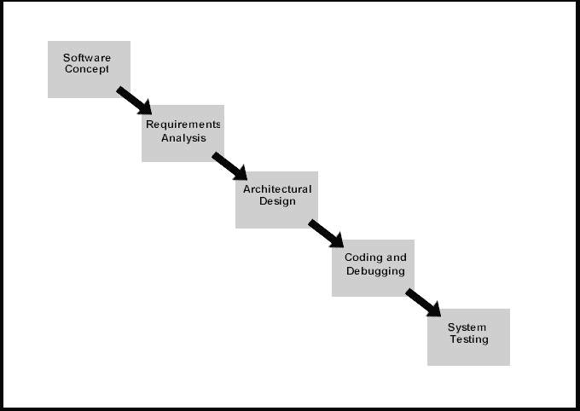

Figure 3.4.1: System Development Life Cycle

**➔ Steps involved in the System Development Life Cycle :**

Below are the steps involved in the System Development Life Cycle. Each phase within the overall cycle may be made up of several steps.

**Step 1: Software Concept**

The first step is to identify a need for the new system. This will include determining whether a business problem or opportunity exists, conducting a feasibility study to determine if the proposed solution is cost effective, and developing a project plan.

This process may involve end users who come up with an idea for improving their work. Ideally, the process occurs in tandem with a review of the organization's strategic plan to ensure that IT is being used to help the organization achieve its strategic objectives. Management may need to approve concept ideas before any money is budgeted for its development.

**Step 2: Requirements Analysis**

Requirements analysis is the process of analyzing the information needs of the end users, the organizational environment, and any system presently being used, developing the functional requirements of a system that can meet the needs of the users. Also, the requirements should be recorded in a document, email, user interface storyboard, executable prototype, or some other form. The requirements documentation should be referred to throughout the rest of the system development process to ensure the developing project aligns with user needs and requirements.

Professionals must involve end users in this process to ensure that the new system will function adequately and meets their needs and expectations.

**Step 3: Architectural Design**

After the requirements have been determined, the necessary specifications for the hardware, software, people, and data resources, and the information products that will satisfy the functional requirements of the proposed system

can be determined. The design will serve as a blueprint for the system and helps detect problems before these errors or problems are built into the final system. Professionals create the system design, but must review their work with the users to ensure the design meets users' needs.

**Step 4: Coding and Debugging**

Coding and debugging is the act of creating the final system. This step is done by software developer.

**Step 5: System Testing**

The system must be tested to evaluate its actual functionality in relation to expected or intended functionality. Some other issues to consider during this stage would be converting old data into the new system and training employees to use the new system. End users will be key in determining whether the developed system meets the intended requirements, and the extent to which the system is actually used.

**Step 6: Maintenance**

Inevitably the system will need maintenance. Software will definitely undergo change once it is delivered to the customer. There are many reasons for the change. Change could happen because of some unexpected input values into the system. In addition, the changes in the system could directly affect the software operations. The software should be developed to accommodate changes that could happen during the post implementation period.

There are various software process models like:-

* + - * + Prototyping Model
        + RAD Model
        + The Spiral Model
        + The Waterfall Model
        + The Iterative Model

Of all these process models we’ve used the Iterative model(The Linear Sequential Model) for the development of our project.

##### Process Model

Process Model Used for the Project : **Iterative Model**

The cascading effect from one phase to the other as is illustrated in figure. In this model each phase well defined starting and ending point, with identifiable deliveries to the next phase.

This model is sometimes referred to as the linear sequential model or the software life cycle

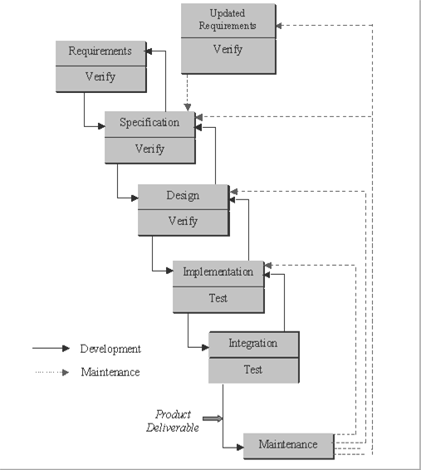

Figure 3.5 : Process Model

The model consists of six distinct stages, namely:

In the **requirements analysis** phase

* + - The problem is specified along with the desired service objectives (goals)
    - The constraints are identified

In the **specification phase** the system specification is produced from the detailed definitions of

1. and (b) above. This document should clearly define the product function.

In the system and software **design phase**, the system specifications are translated into a software representation. The software engineer at this stage is concerned with:

* + Data structure
  + Software architecture
  + Algorithmic detail
  + Interface representations

The hardware requirements are also determined at this stage along with a picture of the overall system architecture. By the end of this stage should the software engineer should be able to identify the relationship between the hardware, software and the associated interfaces. Any faults in the specification should ideally not be passed down stream.

In the **implementation and testing** phase stage the designs are translated into the software domain

* Detailed documentation from the design phase can significantly reduce the coding effort.
* Testing at this stage focuses on making sure that any errors are identified and that the software meets its required specification.

In the **integration and system testing** phase all the program units are integrated and tested to ensure that the complete system meets the software requirements. After this stage the software is delivered to the customer [**Deliverable – The software product is delivered to the client for acceptance testing**.]

The **maintenance** phase the usually the longest stage of the software. In this phase the software is updated to:

* + Meet the changing customer needs
  + Adapted to accommodate changes in the external environment
  + Correct errors and oversights previously undetected in the testing phases
  + Enhancing the efficiency of the software

Observe that feedback loops allow for corrections to be incorporated into the model. For example a problem/update in the design phase requires a ‘revisit’ to the specifications phase. When changes are made at any phase, the relevant documentation should be updated to reflect that change.

**Advantages of the Iterative Model:-**

1. Testing is inherent to every phase of the Iterative model
2. It is an enforced disciplined approach
3. It is documentation driven, that is, documentation is produced at every stage

**Disadvantages of the Iterative Model:-**

The waterfall model is the oldest and the most widely used paradigm. However, many projects rarely follow its sequential flow. This is due to the inherent problems associated with its rigid format. Namely:

* 1. It only incorporates iteration indirectly, thus changes may cause considerable confusion as the project progresses.
  2. As The client usually only has a vague idea of exactly what is required from the software product, this IM has difficulty accommodating the natural uncertainty that exists at the beginning of the project.
  3. The customer only sees a working version of the product after it has been coded. This may result in disaster any undetected problems are precipitated to this stage.

##### Feasibility Study

System Feasibility :

The very first phase in any system development life cycle is early justification. In the preliminary investigations we examine the project viability, the possibility of the system being useful to the automation process. This project has been tested in the following areas of feasibility:

Operational Feasibility:

It was decided that the proposed project could be created as a web application that will meet the operating environment of various applicants from all over the place. The reasons for this conclusion are:

* Business method adopted is acceptable to all users.
* The end user have been involved in the planning and development.
* Manual errors will be reduced.
* It is a user-friendly interface and ensures interoperability.
* It is operationally feasible project considering both the hardware and software factors

.

Technical Feasibility:

It is decided that project is technically feasible because of the following reasons:

∙ Necessary technology exists to do what is suggested.

∙The website is available freely and completely customizable and flexible.

∙The system could be expandable and enhanced if so decided.

Economic Feasibility :

As a part of it, expenses and outcomes associated with the proposed system are compared and the project is economically feasible only if palpable or intangible advantages outweigh the costs. The system development costs will be significant. So the proposed system is economically feasible.

Legal Feasibility :

The licensed copy of the required software is quite cheap and easy to get. So from legal point of view the proposed system is legally feasible.

##### Data Flow Diagrams

A Data Flow Diagram (DFD) is a graphical representation of the “flow” of data through an information system, modeling its process aspects. A DFD is often used as a preliminary step to create an overview of the system without going into great detail, which can later be elaborated.

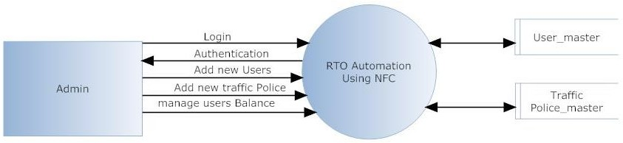

Figure 3.7.1: Admin DFD Diagram

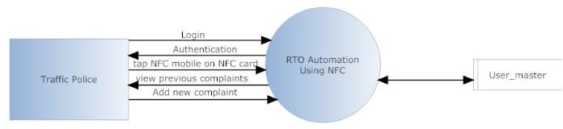

Figure 3.7.1 : Traffic Police DFD Diagram

##### UML Diagrams

* + 1. **Use Case Diagram**

A use case diagram at its simplest is a representation of a user’s interaction with the system that shows the relationship between the user and the different use cases in which the user is involved. A use case diagram can identify the different types of users of a system and the different use cases and will often be accompanied by other types of diagrams as well.

A Use Case diagram is a type of behavioral diagram defined by the UML created

From a use case analysis. Its purpose is to prevent a graphical overview of the functionality provided by a system in terms of actors, and their goal represented as use case. It is a type of diagram that shows a set of use cases, actors and their relationship. It should have a distinct name. It commonly contains:

1. Use Cases
2. 2. Actors (Primary and Secondary)
3. 3. Dependency and Generalization.

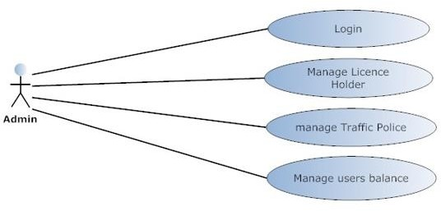

Figure 3.8.1(a): Admin Use Case Diagram

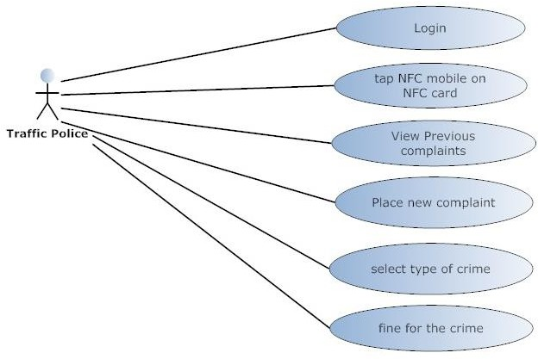

Figure 3.8.1(b): Traffic Police Use Case Diagram

##### Sequence Diagram

A sequence diagram is an interaction diagram that shows how objects operate with one another and in what order. It is a construct of a message sequence chart.Sequence diagram is an interaction diagram that emphasizes the time ordering of messages. A sequence diagram is a structured representation of behavior as a series of sequential steps over time. It is used primarily to show the interactions between objects in the sequential order. The sequence diagram is also called as Message Sequence Chart.

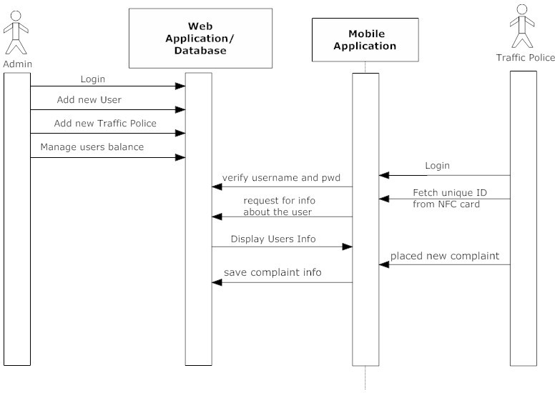

Figure 3.8.2: Sequence Diagram

##### State Level Diagram

A state diagram is a type of diagram used in computer science and related fields to describe the behavior of systems. State diagrams require that the system described is composed of a finite number of states; sometimes, this is indeed the case, while at other times this is a reasonable abstraction. State diagrams are used to give an abstract description of the [behavior](https://en.wikipedia.org/wiki/Behavior) of a [system](https://en.wikipedia.org/wiki/System). This behavior is analyzed and represented by a series of events that can occur in one or more possible states. Hereby "each diagram usually represents objects of a single class and track the different states of its objects through the system".

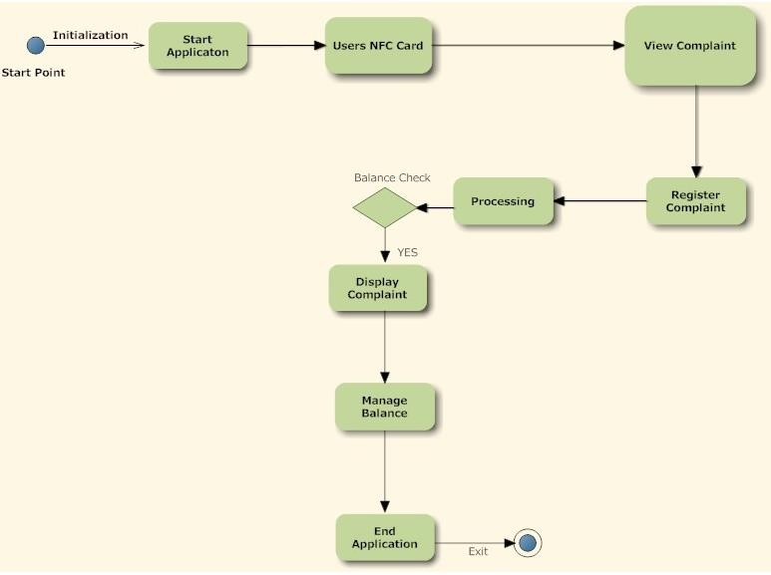

Figure 3.8.3: State Level Diagram

##### Component Diagram

Component diagrams are used in modeling the physical aspects of object-oriented systems that are used for visualizing, specifying, and documenting component-based systems and also for constructing executable systems through forward and reverse engineering. Component diagrams are essentially class diagrams that focus on a system's components that often used to model the static implementation view of a system.

A component diagram breaks down the actual system under development into various high levels of functionality. Each component is responsible for one clear aim within the entire system and only interacts with other essential elements on a need-to-know basis.

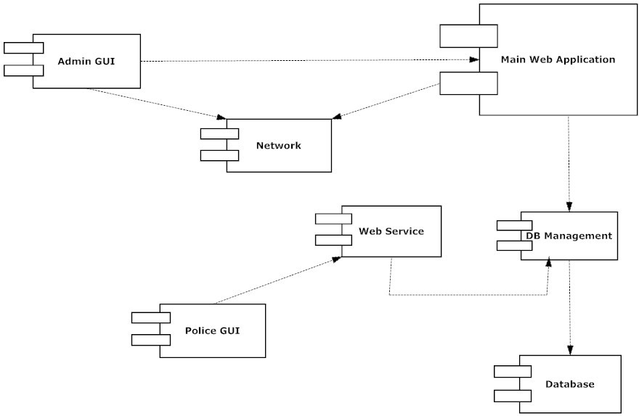

Figure 3.8.4: Component Diagram

##### Activity Diagram

Activity diagrams are graphical representations of workflows of stepwise ac- tivities and actions with support for choice, iteration and concurrency. In the Unified Modeling Language, activity diagrams are intended to model both computational and organizational processes (i.e. workflows).

Activity diagrams are graphical representations of workflows of stepwise activities and actions with support for choice, iteration and concurrency. In the Unified Modeling Language, activity diagrams are intended to model both computational and organizational process.

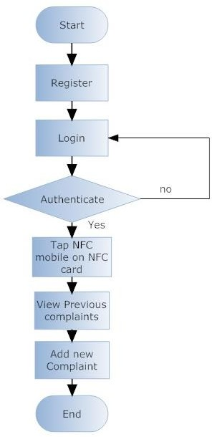

Figure 3.8.5.: Activity Diagram

**CHAPTER 4**

# PLANNING & SCHEDULUNG

### PLANNING AND SCHEDULING

##### 4.1 GANTT CHART

A Gantt chart is a type of bar chart that illustrates a project schedule. They are the most powerful visual in project management. Gantt diagram the start date and the end date for each task that must be done in order to successfully complete a project. The scheduling included a plan for the first half of the year. The plan includes - project title finalization, literature survey, business case, project charter, requirement gathering, security planning, legal planning and user survey, implementation and testing of basic functionality, implementation and testing of GUI, implementation and testing of machine learning functionality, synopsis and report and final presentation. **GANTT chart** The Gantt chart in the above diagram illustrates a project schedule. Gantt charts illustrate the start and finish dates of the terminal elements and summary elements of a project.

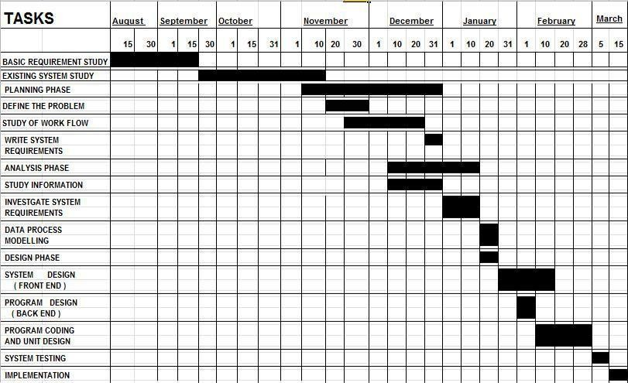

Figure 4.1 : Gantt Chart

2 PERT

Pert Table

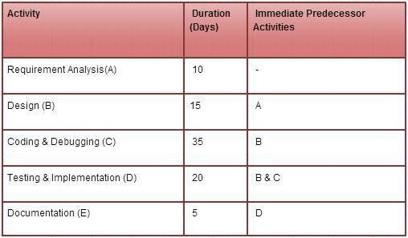

Figure 4.2.1 : Pert Table

Pert Chart

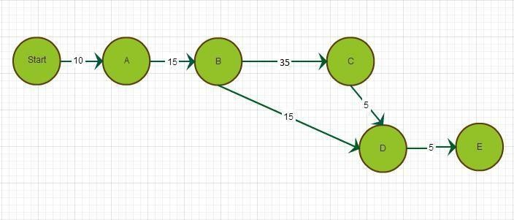

Figure 4.2.2 : Pert Chart

* 1. Timeline

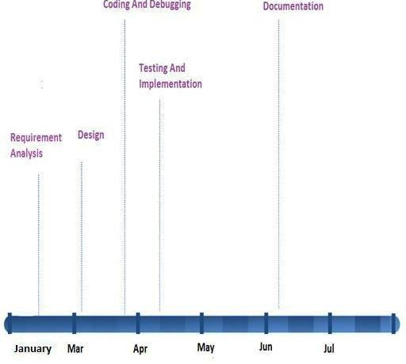

Figure 4.3 : Timeline

* 1. Work Breakdown Structure

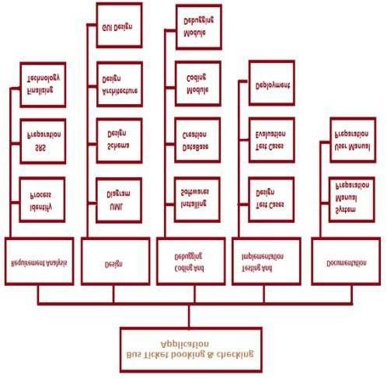

Figure 4.4 : Work Breakdown Structure

**CHAPTER 5**

**TESTING & MAINTENANCE**

* 1. Testing

**Methodologies Used For Testing**

Software testing is an investigation conducted to provide stakeholders with information about the quality of the product or service under test. Software testing also provides an objective, independent view of the software to allow the business to appreciate and understand the risks of software implementation. Test techniques include, but are not limited to, the process of executing a program or application with the intent of finding software bugs (errors or other defects).

Software testing can also be stated as the process of validating and verifying that a software program/application/product:

* + Meets the business and technical requirements that guided its design and development
  + Works as expected; and
  + Can be implemented with the same characteristics.

**Primary Purpose:**

Testing is to detect software failures so that defects may be discovered and corrected. This is a non- trivial pursuit. Testing cannot establish that a product functions properly under all conditions but can only establish that it does not function properly under specific conditions.

**Scope:**

The scope of software testing often includes examination of code as well as execution of that code in various environments and conditions as well as examining the aspects of code: does it do what it is supposed to do and do what it needs to do. In the current culture of software development, a testing organization may be separate from the development team.

**Implementation:**

Software testing, depending on the testing method employed, can be implemented at any time in the development process. However, most of the test effort occurs after the requirements have been defined and the coding process has been completed. As such, the methodology of the test is governed by the software development methodology adopted.

**Software Testing Model**

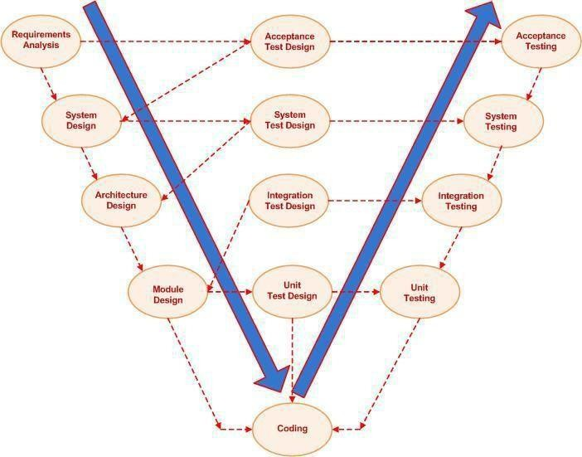

Figure 5.1 : Software Testing Model

The V-model involves building a logical V shape sequence where the testing techniques associated with the design are reflected as descending and are applied for the “verification” and connected to the requirements or specifications parts are reflected as ascending and are applied for “validation”.

The V-model ordains that the code testing documentation is written in tandem with the development phases that means, for instance, the integration tests should be documented as and when the high level design is finalized and the unit tests should be ready as and when the detailed specifications are laid down.

The idea of the V-model is to have a implementation plan for the software testing at each level namely component, interface, system, acceptance and release of the software project which need to be adhered to eliminate discrepancies in the software simultaneously rather

than waiting for the software development process to complete before handling it to the software testing professionals.

**Testing Technology**

System testing is a critical phase implementation. Testing of the system involves hardware devise and debugging of the computer programs and testing information processing procedures. Testing can be done with text data, which attempts to stimulate all possible conditions that may arise during processing. If structured programming Methodologies have been adopted during coding the testing proceeds from higher level to lower level of program module until the entire program is tested as unit. The testing methods adopted during the testing of the system were unit testing and integrated testing.

**Unit Testing:**

Unit testing focuses first on the modules, independently of one another, to locate errors. This enables the tester to detect errors in coding and logical errors that is contained within that module alone. Those resulting from the interaction between modules are initially avoided.

**Integration Testing:**

Integration testing is a systematic technique for constructing the program structure while at the same time to uncover the errors associated with interfacing. The objective is to take unit- tested module and build a program structure that has been detected by designing. It also tests to find the discrepancies between the system and its original objectives. Subordinate stubs are replaced one at time actual module. Tests were conducted at each module was integrated. On completion of each set another stub was replaced with the real module.

**Functional Testing:**

Functional testing is a technique in which all the functionalities of the program are tested to check whether all the functions that where proposed during the planning phase are full filled. This is also to check that if all the functions proposed are working properly.

This is further done in two phases:

* + - One before the integration to see if all the unit components work properly
    - Second to see if they still work properly after they have been integrated to check if some functional compatibility issues arise.

**Performance Testing:**

Expected Result

* The client should be able to connect to the server properly without any problems.
* The connection establishment between the mobile device and the server should take minimal time.
* The mobile device should be able receive data from the server uninterruptedly.
* Information provided by the application should be correct and as per the user’s need.

Observation

* Connection can be established easily provided that the server is on.
* The connection with the server takes time as it uses Internet connection.
* Receiving data from the server takes time.
* Information coming from the database is correct.

**Load / Stress Testing :**

Expected Result

* Response time should be unaffected irrespective of the no of users.
* The introduction of the newer clients should not make the server to work hap hazardously.
* Continuous use of the server by different clients should not result into the server getting slowed down.
* Response time should not be degraded if there is congestion in network.

Observation

The speed of transmission was fine even when the newer clients were getting added. The response of the server was satisfying even with the introduction of newer client.

**Types of Testing** **White Box Testing**

White box testing is performed based on the knowledge of how the system is implemented. White box testing includes analyzing data flow, control flow, information flow, coding practices, and exception and error handling within the system, to test the intended and unintended software behaviour. White box testing can be performed to validate whether code implementation follows intended design, to validate implemented security functionality, and to uncover exploitable vulnerabilities.

White box testing is used to test areas that cannot be reached from a black box level. White box testing uses an internal perspective of the system to design test cases based on internal structure. It requires programming skills to identify all paths through the software. The tester chooses test case inputs to exercise paths through the code and determines the appropriate outputs.

**Branch coverage**

Branch coverage exclusively considers the logical value of the result of a condition (true or false). ‘Social Networking App’ contains many conditions which has effect on overall working of the application. Selection of date range, category has overall effect on expense. Such cases are tested in branch coverage.

**Path coverage**

Path coverage requires the execution of all different paths through the test object. This is important with respect to mobile application. Application should execute all the paths and should not crash in between.

**Black Box Testing**

Black-box testing is a method of software testing that tests the functionality of an application as opposed to its internal structures or workings. Specific knowledge of the application's code/internal structure and programming knowledge in general is not required.

Test cases are built around specifications and requirements, i.e. what the application is supposed to do. It uses external descriptions of the software, including specifications, requirements, and

designs to derive test cases. These tests can be functional or non-functional, though usually functional. The test designer selects valid and invalid inputs and determines the correct output. There is no knowledge of the test object's internal structure. This method of test can be applied to all levels of software testing: unit, integration, functional, system and acceptance.

Black-Box testing helps to find errors such as-

* + Incorrect or missing functions
  + Interface errors
  + Errors in data structures

**Equivalence class partitioning**

Test case for input fields such as username, password, etc. are prepared and tested. Equivalence class partitioning helps to reduce total time in testing by dividing valid and invalid test cases.

**Boundary value analysis**

Faults often occur at the boundary of equivalence classes, because boundaries are not often defined clearly or misunderstood by programmers. Application having range fields such as date ranges are tested using this technique.

**State transition testing**

In many cases, not only current input, but also the history of execution or events or inputs, influences the outputs. Application has many fields such as date, category which has different effects on overall application. Minor change in each of them triggers changes in lot of input methods. These fields are tested under state transition testing.

* 1. Maintenance

Maintenance is an enigma of the system development. It holds the software industry captive. Analysts spend more time in maintaining programs than coding them. Software maintenance denotes any changes made to the software product after it has been delivered to the customer. Most products need maintenance due to the wear and tear of the product. Software Maintenance can be divided into following types:

**Corrective Maintenance:**

It is necessary to rectify the bugs observed while the system is in use. **Interview Tracking System** needs this maintenance for any removing flaws that can arise while sending the data or for correcting the logical bugs that might have been left unchecked as they appear only in real time like empty database.

**Perfective Maintenance:**

Software product might need maintenance to support the new features that users want it to support, to change different functionalities of the system according to the customer demands, or to enhance the performance of the system. **Interview Tracking System** needs this maintenance for removing the short falls of its current features.

Software Maintenance is essential as initial stages of any software developed are always unstable. Over the time it achieves stability as bugs are fixed and faults are removed to make the system accurate.

System Maintenance is often termed as the task of doing repairs to the developed system. When websites are inaccessible due to attacks from hackers, server problems or for updating and repair, the administrators of the website will often display an image apologizing for System Maintenance and Website downtime. This allows the user to understand that the website cannot be used and that the administrators are aware of the issue.

**Evaluation**

System Evaluation is termed as the task of evaluating the success and failure of the system. It is performed with the help of following two V’s:

**Verification**

Verification determines whether the system is built correctly and does not contain technical errors. It also involves the review of the requirements, to verify that the right problem is being solved. Verification also ensures that the system is syntactically and logically correct and performs functionally as being specified. It is a static practice of verifying documents, design, code and program.

As verification relates to the humanized effort of checking the documents and files, we have taken utmost care to see to it that the application conforms to specifications. Reviews and inspections were carried out periodically. The web based application has been put through the process of Verification successfully.

**Validation:**

Validation on the other hand is a difficult task of insuring the meaning and content of the rules meet some carefully defined criteria of adequacy. Defining such criteria is the key to successfully conduct Validation procedure and demonstrating the level of acceptability of the system.

As Validation is a dynamic mechanism of validating and testing the actual product; we have implemented the process of validation by executing the code thoroughly. By performing White Box as well as Black Box testing; along with Acceptance Testing, we have made sure that the application adheres to customer’s expectation and requirements.

The target for validation was actual product-a unit, a module, a bent of integrated modules, and effective final product.

* + **Verification** process describes whether the outputs are according to inputs or not.
  + **Validation** process describes whether the software is accepted by the user or not.

**CHAPTER 6**

# SYSTEM IMPLEMENTATION

##### Results

* + 1. **Splash Screen**



Figure 6.1.1:Splash Screen

* + 1. **User Activity**

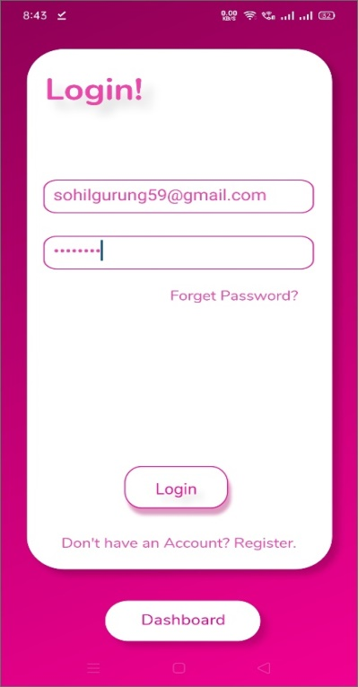

Figure 6.1.2(a) : User Login Page

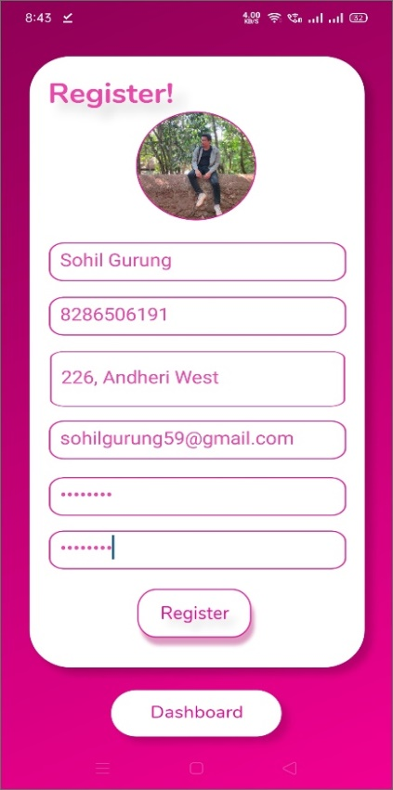

Figure 6.1.2(b): User Registration page

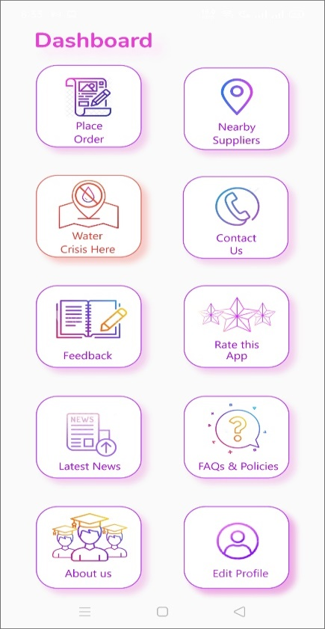

Figure 6.1.2(c): Dashboard

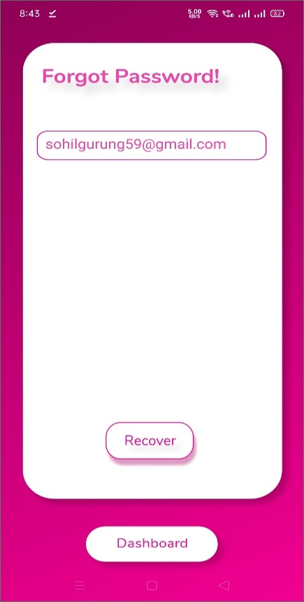

Figure 6.1.2(d): Forgot password

* + 1. **Map Activity**

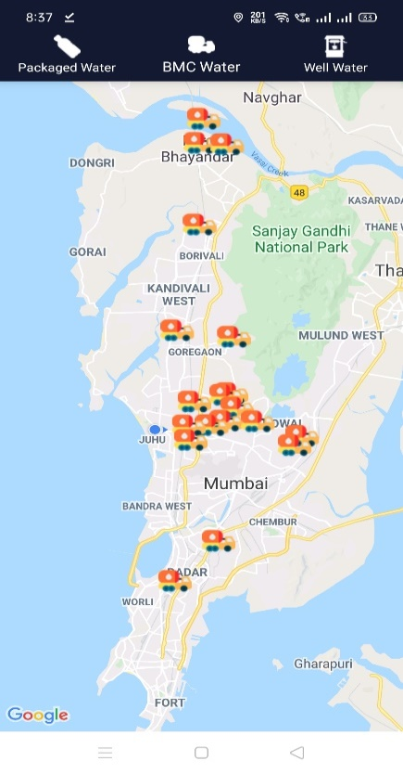

Figure 6.1.3(a): Suppliers

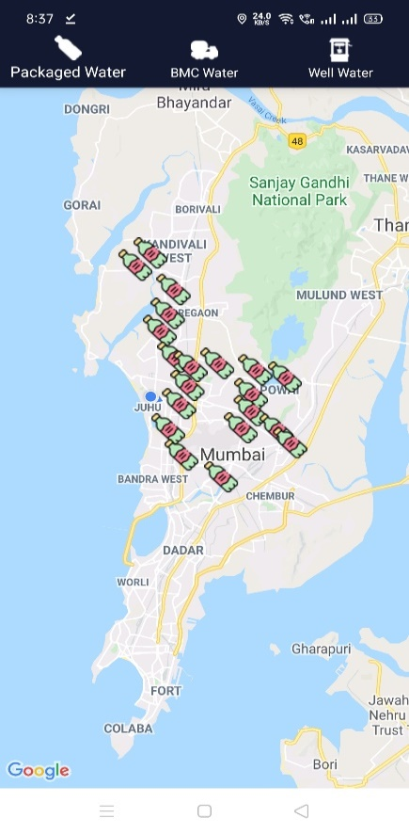

Figure 6.1.3(b): Package Water

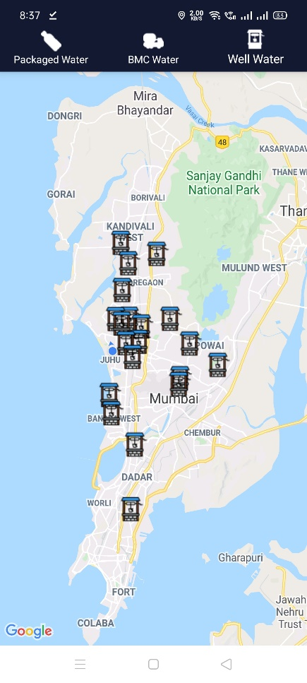

Figure 6.1.3(c): Well Water

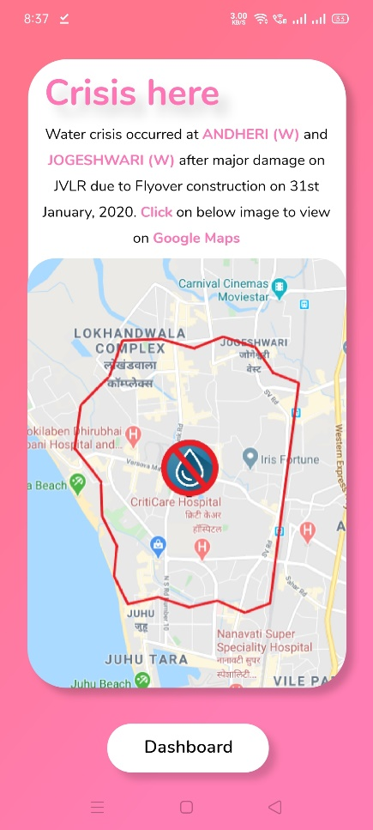

Figure 6.1.3(d): Crisis here

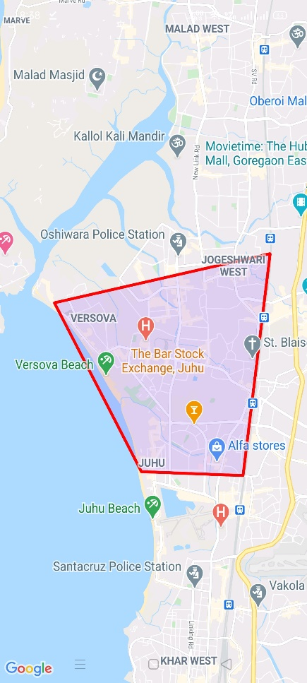

Figure 6.1.3(e): Crisis Area

* + 1. **Show Entities**

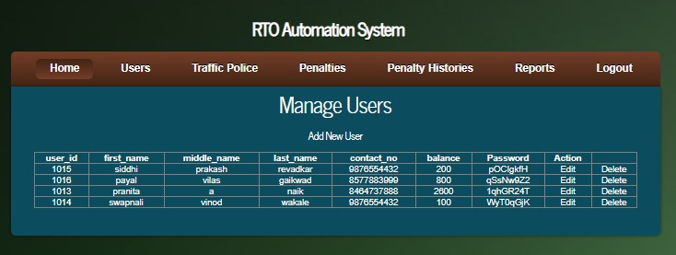

Figure 6.1.4(a): User List

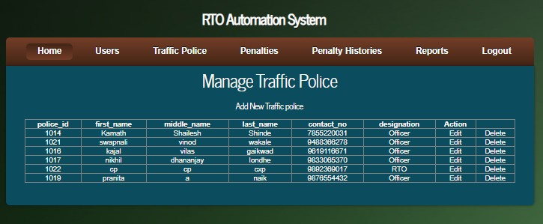

Figure 6.1.4(b): Traffic Police List

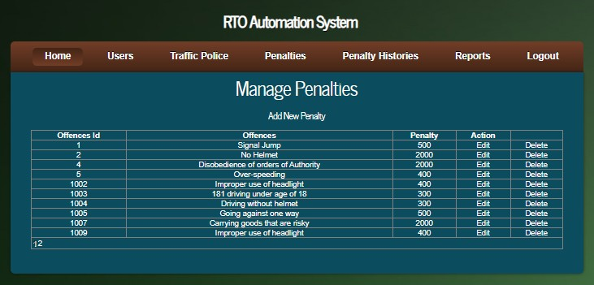

Figure 6.1.4(C): Penalty List

* + 1. **Penalty History**

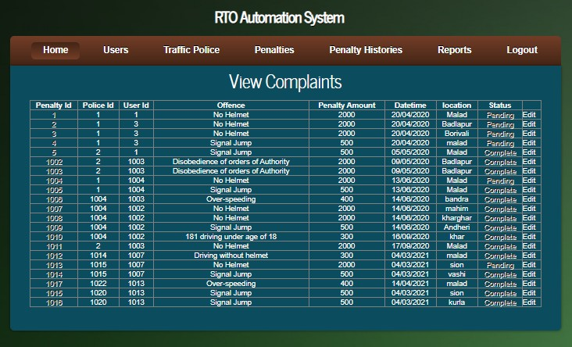

Figure 6.1.5: Penalty History

* + 1. 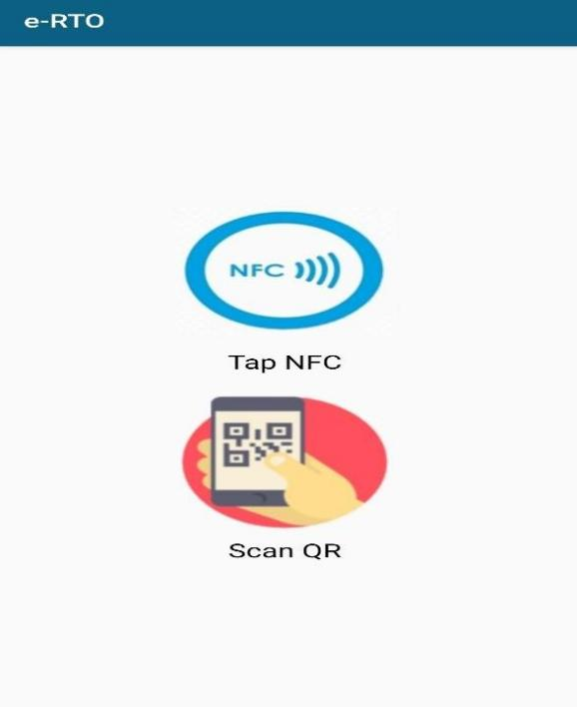**NFC/QR Scanner**

Figure 6.1.6: NFC/QR Scan page

* + 1. **User Details**

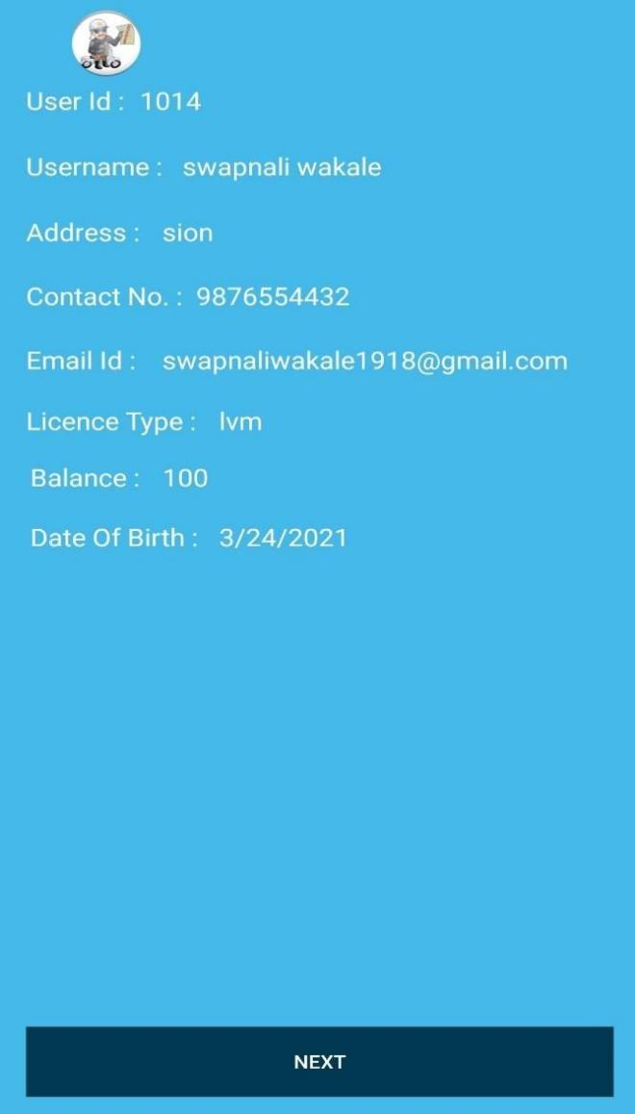

Figure 6.1.7: User Details

* + 1. **Users Penalty**

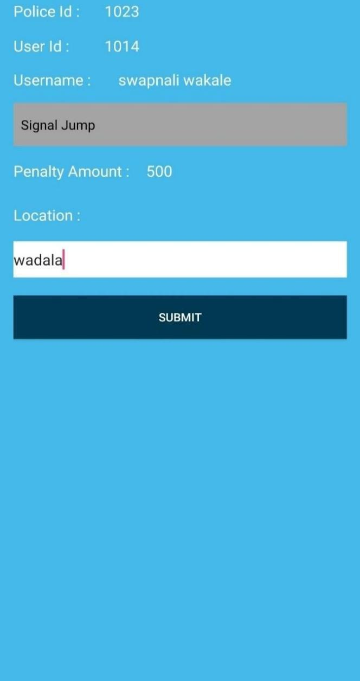

Figure 6.1.8: Users Penalty

**CHAPTER 7 CONCLUSION & FUTURE SCOPE**

**CONCLUSION & FUTURE SCOPE**

##### Conclusion

The current working strategy is old fashioned and there is no usage of commonly used technologies like internet, & android. Thus, it can be concluded that the proposed application effectively provides the solution to current working method. This application introduces facility for customer to place orders, place complaint (if any) and give feedback to seller. It also helps the shopkeeper to maintain records systematically and reduces a lot of paperwork and manual efforts. The application provides lots of advantages like shop locator, customize orders, enhanced user interface, delivery options, order process estimate, order status and may more.

##### Future Scope

Advancements in a project such as Better optimization can be done, live tracking of order can be added, recommendation of nearby suppliers based on customers order, currently this app is based for ANDROID user only for IOS user same app will implemented, these features are left as a future scope to work upon.

**CHAPTER 8**

# REFERENCES

### REFERENCES

1. Mayurkumar Patel,“Online Food Order System for Restaurants”,2015.
2. Abdul shaban. “Water Poverty in Urban India: A Study of Major Cities. Mumbai: Tata Institute of Social Science”, 2008.
3. <https://www.ripublication.com/ijaer18/ijaerv13n16_17.pdf>
4. <https://www.ijcsmc.com/docs/papers/May2015/V4I5201557.pdf>

**PAPER PUBLISHED**

**CERTIFICATES**

### RTO Automation Using NFC/QR Code



**International Journal of Advances in Engineering and Management (IJAEM) Volume 3, Issue 3 Mar. 2021, pp: 295-300** [**www.ijaem.net**](http://www.ijaem.net/) **ISSN: 2395-5252**

###### Prof. Ajitkumar Khachane1, Payal Gaikwad2, Swapnali Wakale3, Pranita Naik4

*Professor, Information Technology, VIT, Wadala, India1 Student, Information Technology, VIT, Wadala, India2,3,4*

- Submitted: 25-02-2021 Revised: 05-03-2021 Accepted: 10-03-2021

**ABSTRACT**: French drivers are now being issued with new multi-application driving licenses based on contactless smart cards that contain both a public and a private data area. The private area can only be accessed and verified by police and other authorities while the public area can be read by an NFC phone and used by third parties to, for instance.

The new licenses are being introduced by Imprimerie Nationale, the French national printing works, and use Gemalto‟s Sealysmulti-application electronic driving license technology.

The polycarbonate driving licenses house an ISO 14443 compliant microprocessor that includes two storage areas, one for public and one for private data. The private space will be used to store driving license data so that it can be verified by police officers in cases involving suspected fraud or other criminality. The space provisioned for public usage will be offered to a variety of service providers and will be able to be read by an NFC phone.

**Keywords:** NFC, License, Android, RTO, QR code, Corruption, Violation.

* + - 1. **INTRODUCTION**

The need for manual RTO based systems is completely reduced in this method and the RTO system works through NFC.A complete NFC system consists of a transponder (tag), reader/writer and computer host. The transponder, better known as the tag. The microchip contains memory to store a unique data and to receive and send data back to the reader. These tags are powered by the electromagnetic signal received from a reader. Development in technology bring digital world to be border-less. It's proven through a developed technology, when trade and transaction can be done not only using real money but also virtual one. Shopping process using virtual money has even more supported by existed Near Field Communication (NFC) device. This particular

device works using radio frequency. In the year of 2011, Google was integrating this device into a Android-based cell phone, which made transactions using virtual money gradually developed.

The NFC tag is used as a unique identity for account of a particular user. When a vehicle driver caught bay a traffic police, its driver is prompted to scan his NFC tag. If the identity (serial number of the tag) is matched withthe one already stored in the system, the historical records of that driver get fetch on a mobile phone. Traffic police can also placed a new complaint about that driver. If police placed a new complaint then the fine amount will get deducted from his total balance. After this, the vehicle gets immediate access to drive through. This NFC based RTO system also has some additional features. A new user can register him with the system. Also an old user can recharge his account balance. The amount for recharge can be entered in the system. In beginning, the user is prompted to scan his tag or ID. The serial code of the tags identified by the reader module and is sent for comparison with stored data. If the ID is matched by the microcontroller, the fine amount is deducted from user‟s balance and user gets to drive through the area.

* + - 1. **PROBLEM STATEMENT**

“Most police departments have members who commit corrupt acts from time to time. Only some police departments, however, become corrupt policedepartments.” [1]

As was suggested at the outset, there are many competing definitions of corruption. There are broad, inclusive definitions which suggest that police corruption is „loosely‟ identified as

„deviant, dishonest, improper, unethical or criminal behaviour by a police officer.‟ [2] There are also significantly narrower definitions. James Q Wilson. [3] for example, distinguishes between activities such as accepting bribes (which he along with everyone else considers to

be the prototypical form of corrupt behaviour) and „criminal‟ activities such as burglary on duty (which he considers to be qualitatively different



**International Journal of Advances in Engineering and Management (IJAEM) Volume 3, Issue 3 Mar. 2021, pp: 295-300** [**www.ijaem.net**](http://www.ijaem.net/) **ISSN: 2395-5252**

– criminal but not corrupt). Although both acts are criminal, the point of Wilson‟s distinction is that bribery in a way that burglary by police officers need not. There is a parallel here with work on so-called „white collar crime.‟ [4]

* + - 1. **PROPOSED SYSTEM**

Many modern smart phones and tablets have an integrated scanner that can read NFC chips. All one needs to do for driver's licence checks is attach a single low-cost NFC chip to the driver's licence.

The NFC chip stores a unique combination of numbers. This ID will be read by the smartphone and the NFC to web app with the underlying NFC technology and uniquely associated with the driver's master data in the web application.

Now the drivers can perform the automated checks with NFC to web application. They just need to hold their driver's licences up to their smartphones. The phone scans the chip and fetch the unique id from the chip. The data connection can be either through a mobile data connection or via a local wireless network.

* + - 1. **IMPLEMENTATION**

The proposed system consist of three modules which work simultaneously which are as follows:

1. Admin Module:-

* admin can login into the application.
* admin check the documents and if those documents are legal then he will make a new user account into the application and provide a new licence to the user.
* after creating a new user account user will get the username and password by mail.

1. Traffic Police Module:-

* Traffic police login to the androidapplication.
* if any user caught by traffic police then police will get the driving licence and tap using android phone.
* after tapping, police can view the previous records,can placed a new complaint.
* after placing a new complaint the fine amount willget deduct from a total balance of the user.

1. User Module:-

* User can login into the system using username andpassword.
* User can view the complaints which are placedagainst him.

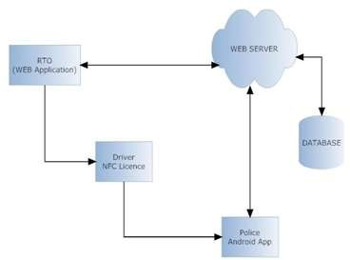

**Fig 1.** ArchitectureNear Field Communication :

Near Field Communication is a wireless close-range connectivity technology which allows data trade between two gadgets. NFC commonly integrated withinmobile devices. This

will allow the device to establish communication with simcard or other reader devices. NFC works using 13,56 MHz radio frequency. This technology optimizely works under the space of

20 cm. Transmittable data is only less than 1Mbit. This technology developed in 2004. NFC Concept Nevertheless, the main reason to apply this technology is to be implemented within ticketing application, payment application and public transportation application. When a cell phone equipped with NFC deviced, that particular cellphone can be used as ticket of conference or theme park and also a “mini wallet” which can be used in certain time. Moreover, the cell phone can also be used as payment tool and an automatic machine, toll payment, and some other transactions. NFC application is also can be used on a public transportation as a substitute of wallet and as a tool to ticket data writing. Basically NFC has 2 different communications which work on different speed, consist of:



**International Journal of Advances in Engineering and Management (IJAEM) Volume 3, Issue 3 Mar. 2021, pp: 295-300** [**www.ijaem.net**](http://www.ijaem.net/) **ISSN: 2395-5252**

* Active NFC Mode, in this mode, inisiator and target use self-establised radio frequency to communicate.
* Passive NFC Mode, in passive mode, target answer command made by inisiator to call modulation scheme. Inisiator do the radio frequency creation.

**A**ndroid Based NFC Reader:

The usage of NFC can be done through 3 major ways: card emulation, reader mode, peer to peer (P2P) mode. The function of NFC introduced by Google into Android

2.3 (API level 9) device. In Android 2.3, the ability of device is limited in only reading the tag. In Android 2.3 data writing and trading ability through mode Peer to Peer (P2P) began to be implemented within android devices. The nfc android package provides access to NFC function, allows application to read NDEF message (NFC Data Exchange Format) which located at NFC tag. On android.nfc, located several classes which can be used to running NFC function.

* + - 1. **REQUIRREMENT ANALYSIS Hardware Requirements:**
* NFC tags
* NFC based Android Mobile
* Intel processor IV and above
* 1 GB RAM
* 160 GB hard disk

Software Requirements:

* Visual Studio 2010
* MS SQL Server 2005
* SDK for Android 4.2
* Windows Operating System
* Eclipse
  + - 1. **FEASIBILITY**

Operational Feasibility:

The site will reduce the time consumed to maintain manual records and is not tiresome and cumbersome to maintain the records. Hence operational feasibility is assured.

Technical Feasibility :

* At least 166 MHz Pentium Processor or Intel compatible processor.
* At least 16 MB RAM.
* 14.4 kbps or higher modem.
* A video graphics card.
* A mouse or other pointing device.
* At least 3 MB free hard disk space.
* Microsoft Internet Explorer 4.0 or higher.

Economical Feasibilty:

Once the hardware and software requirements get fulfilled, there is no need for the user of our system to spend for any additional overhead. For the user, the web site will be economically feasible in the following aspects:

* The web site will reduce a lot of paper work. Hencethe cost will be reduced.
* Our web site will reduce the time that is wasted inmanual processes.
* The storage and handling problems of the registerswill be solved.

Design Details:

1. DFD diagram:

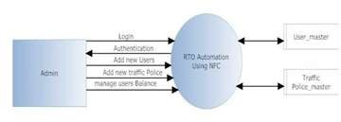

**Fig 4.** Admin DFD diagram

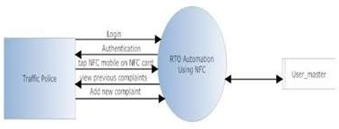

**Fig 3.** Traffic Police DFD diagram

1. Use case diagram:

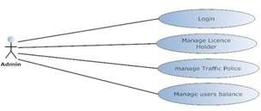

**Fig 4.** Admin Use Case diagram

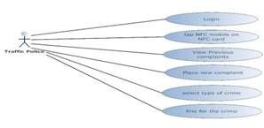

**Fig 5.** Traffic Police Use Case Diagram



**International Journal of Advances in Engineering and Management (IJAEM) Volume 3, Issue 3 Mar. 2021, pp: 295-300** [**www.ijaem.net**](http://www.ijaem.net/) **ISSN: 2395-5252**

1. Activity diagram:

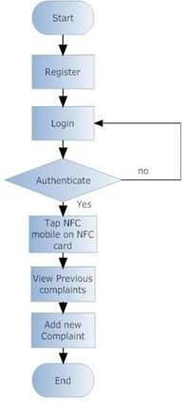

**Fig 6.** Activity diagram

1. State level diagram



**International Journal of Advances in Engineering and Management (IJAEM) Volume 3, Issue 3 Mar. 2021, pp: 295-300** [**www.ijaem.net**](http://www.ijaem.net/) **ISSN: 2395-5252**

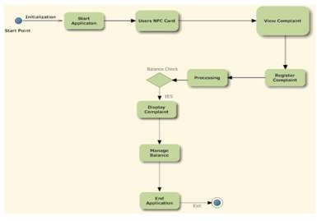

* + - 1. **CONCLUSION**

**Fig 7.** State level Diagram

applications of NFC include:

When a vehicle driver caught bay a traffic police, its driver is prompted to scan his NFC tag. If the identity (serial number of the tag) is matched with the one already stored in the system, the historical records of that driver get fetch on a mobile phone. Traffic police can also placed a new complaint about that driver. If police placed a new complaint then the fine amount will get deducted from his total balance. After this, the vehicle gets immediate access to drive through. This NFC based RTO system also has some additional features. A new user can register him with the system. Also an old user can recharge his account balance.

* + - 1. **FUTURE SCOPE**

NFC could be used for so much more than just data transfer and payments. We can purchase our tickets, reserve hotel, unlock and lock rooms and cars etc. The truth is that all of this and more is possible with NFC.As long as vendors get a reader that supports NFC, capable phones can quickly and easily send information to those devices. With Android, Nokia and Blackberry all in various stages of supporting NFC, the pressure to offer support as well to avoid falling behind in a technologically advanced world. Some current as well as developing

Google Wallet: Google‟s smartphone program that allows users to load credit card information and payment. Visa and Samsung have partnered to create a NFC compatible smartphone geared at fans of the Olympics. This smartphone will carry special content and aims to make purchases and other interactions at the Olympic Games faster and easier. As other cell phone manufacturers race to keep up, NFC could grow substantially and being offered on more and more devices. All in all, the future of NFC looks bright.

**REFERENCES**

1. Andreou, A. S., dkk. Mobile Commerce Applications and Services: A Design And Development Approach. Cyprus:

University ofCyprus

1. Alfawaer, Zeyad M. 2011. Mobile E- Ticketing Reservation System for Amman International Stadium in Jordan. Jordan: International Journal of Academic Research
2. Near Field Communication: ECMA International Standardizing Information and Communication Systems. Geneva.
3. Near Field Communication in the real world – part II. United Kingdom:

Innovision Research & Technology plc.



**International Journal of Advances in Engineering and Management (IJAEM) Volume 3, Issue 3 Mar. 2021, pp: 295-300** [**www.ijaem.net**](http://www.ijaem.net/) **ISSN: 2395-5252**

1. Near Field Communication. Deventer: ICT Communication & Multimedia.
2. Android SDK Developer Guide. [Online].

Available[: http://developer.android.com](http://developer.android.com/)

1. Murphy, Mark L. 2010. Beginning Android 2. United State of America : Apress.
2. Hashimi, Sayed, Satya Komatineni, Dave MacLean. 2010. Pro Android 2. United State of America : Apress.
3. Mednieks, Zigurd, Laird Dornin, G. Blake Meike, & Masumi Nakamura. 2011. Programming Android. United State of America : O‟Reilly.

